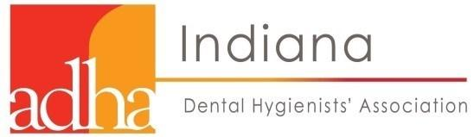

2020 General Assembly Motion Form

DATE: Resolution/Bylaw #:
COMPONENT:
NAME:
I move

Please email this completed form to:
Sharon Paterson (paterson4idha@gmail.com) and Barb Owens (idhacentraloff@gmail.com) by November 5, 2020

